NJROTC Leadership Award
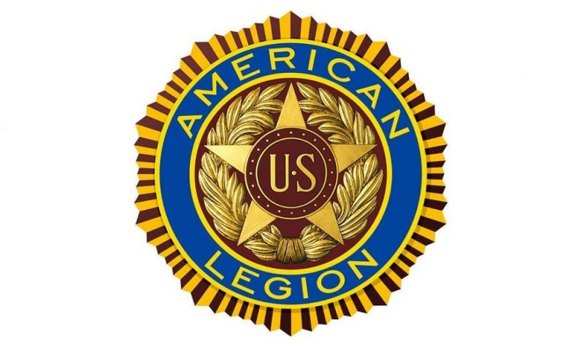
American Legion Post 109
Falmouth, KY

The American Legion was chartered and incorporated by Congress in 1919 as a patriotic veterans organization devoted to mutual helpfulness.

Requirements:

- The recipient(s) of this award must be graduating PCHS senior cadet(s) enrolled in the NJROTC program.

- The amount of this award is $500 and can be divided between several cadets if the instructors deem necessary. A check will be paid directly to the cadet(s).

- The NJROTC instructors will select the recipient(s) of this award without prejudice regardless of race, creed, color, national origin, or sex.

- This award will be based on the combination of need, patriotism, NJROTC / school / community involvement, grades and attendance.

- The NJROTC instructors will notify the American Legion of their selection. Check(s) will be drafted by the Post for presentation at the Senior Scholarship/Awards Night.

